Test Case: tc002_SPX_Dev5_Crear_Requisicion_Spot_Con_FAD_Tipo_Cobro_CC
Step 1 - Enter username and password and click to button Enter : Credentials Entered
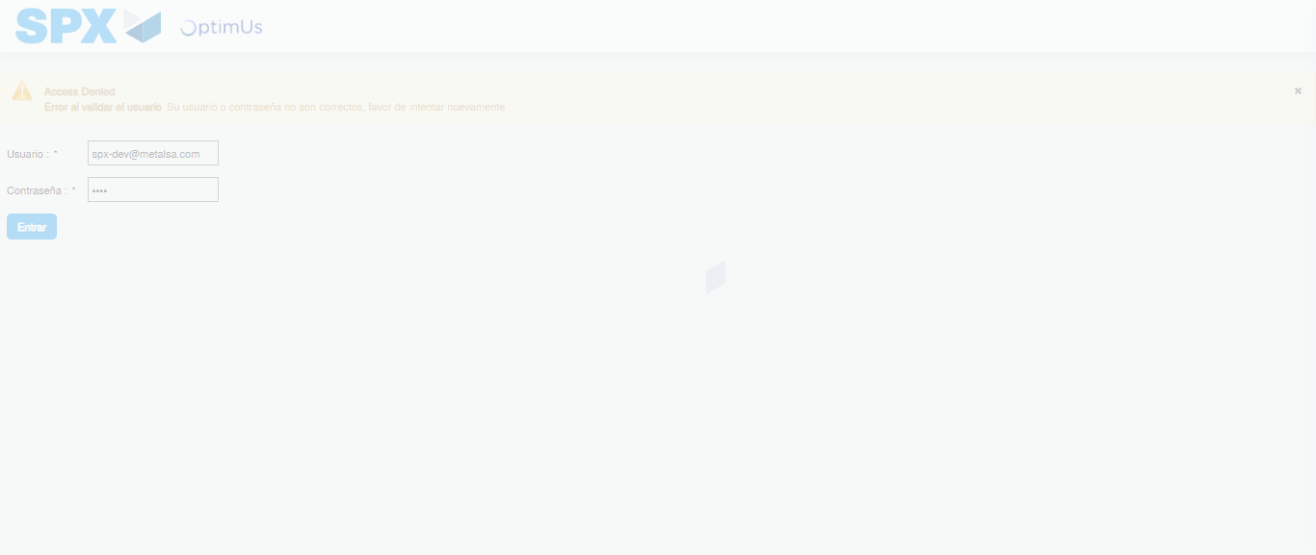Image file-name: QC_Testing-tc002_SPX_Dev5_Crear_Requisicion_Spot_Con_FAD_Tipo_Cobro_CC-1789483530195

Step 2 - Select to UEN and Access to Spot Buy Requisitions : UEN Correctly selected and Correct access
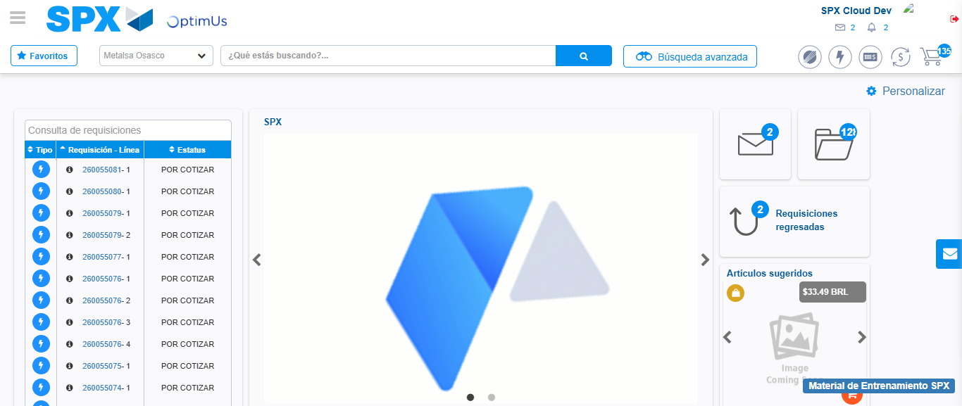Image file-name: QC_Testing-tc002_SPX_Dev5_Crear_Requisicion_Spot_Con_FAD_Tipo_Cobro_CC-1789483553641

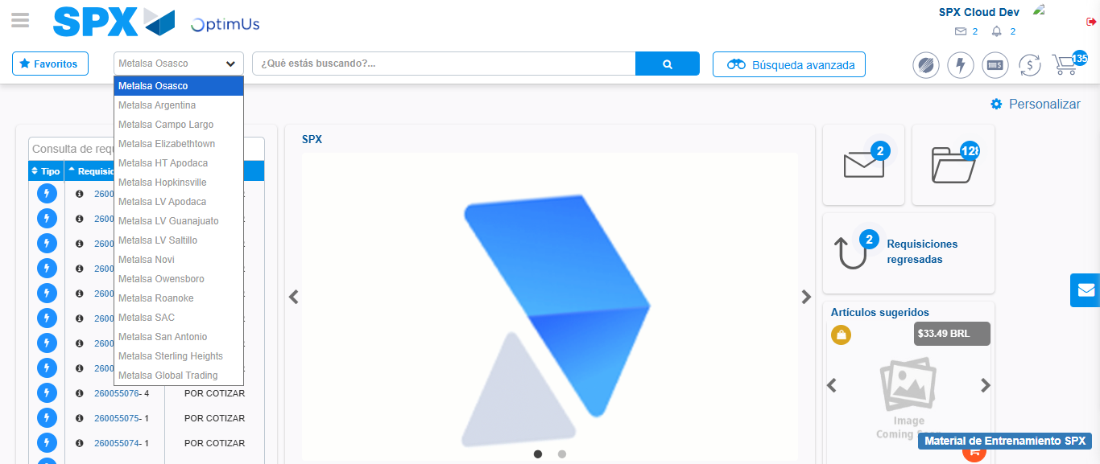Image file-name: QC_Testing-tc002_SPX_Dev5_Crear_Requisicion_Spot_Con_FAD_Tipo_Cobro_CC-1789483554330

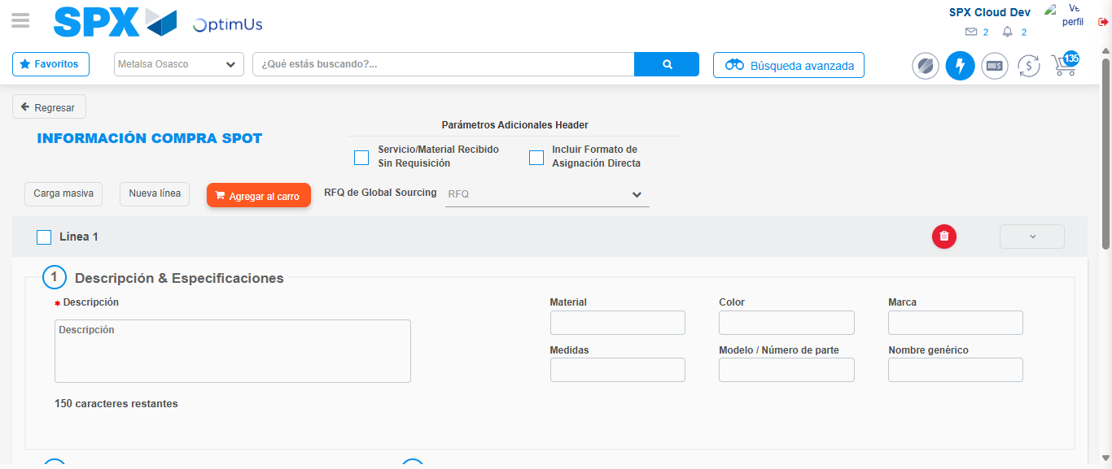Image file-name: QC_Testing-tc002_SPX_Dev5_Crear_Requisicion_Spot_Con_FAD_Tipo_Cobro_CC-1789483563550

Step 3 - Add FAD to Requisition: FAD Successfully Added
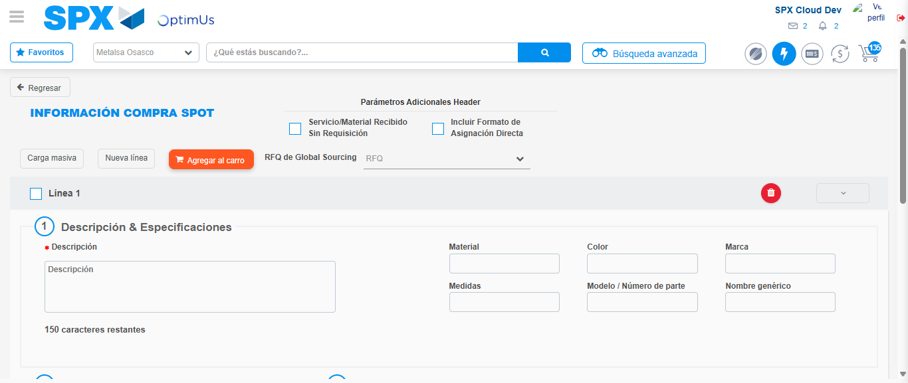Image file-name: QC_Testing-tc002_SPX_Dev5_Crear_Requisicion_Spot_Con_FAD_Tipo_Cobro_CC-1789483563847

Image file-name: QC_Testing-tc002_SPX_Dev5_Crear_Requisicion_Spot_Con_FAD_Tipo_Cobro_CC-1789483564040

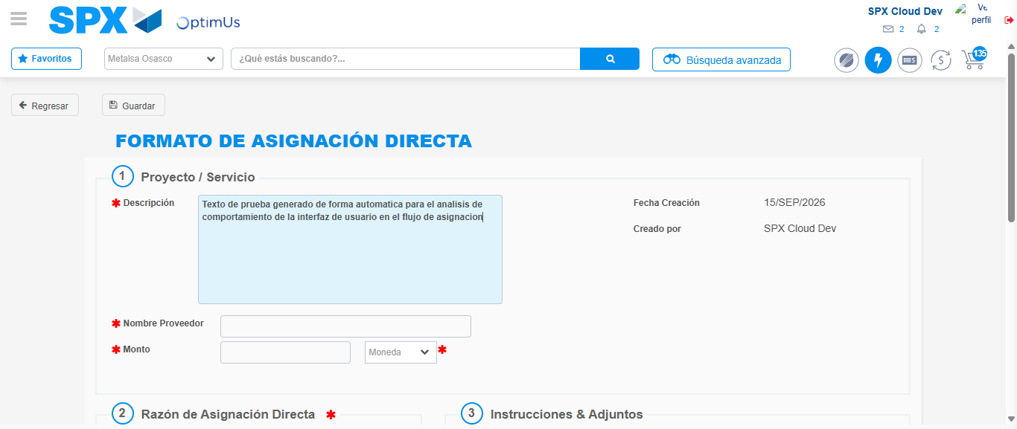Image file-name: QC_Testing-tc002_SPX_Dev5_Crear_Requisicion_Spot_Con_FAD_Tipo_Cobro_CC-1789483566978

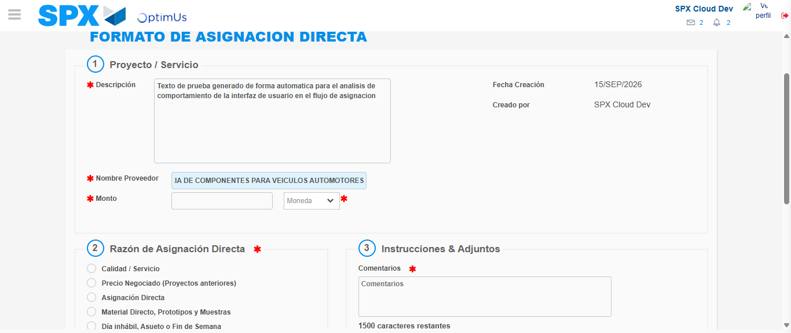Image file-name: QC_Testing-tc002_SPX_Dev5_Crear_Requisicion_Spot_Con_FAD_Tipo_Cobro_CC-1789483576093

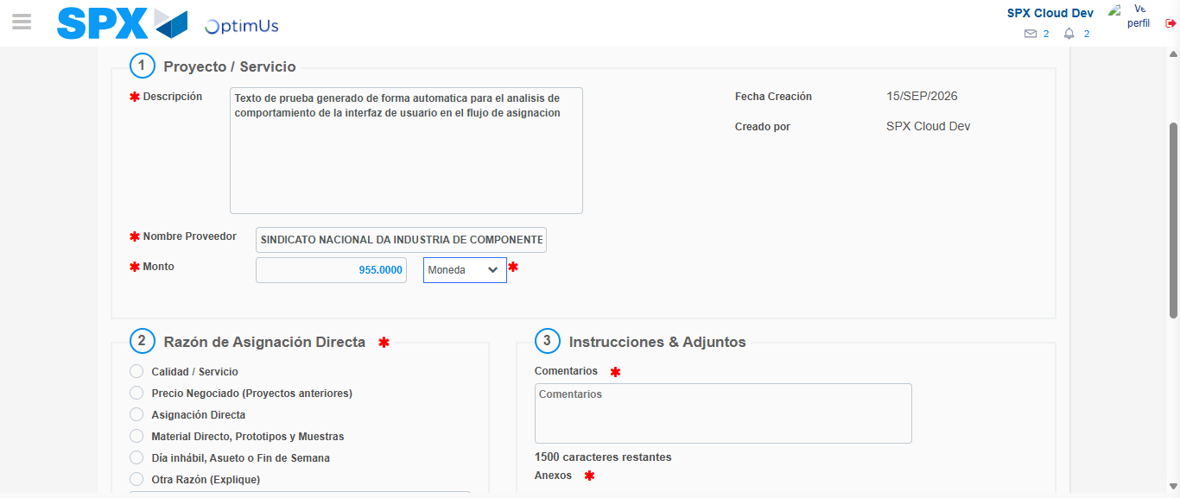Image file-name: QC_Testing-tc002_SPX_Dev5_Crear_Requisicion_Spot_Con_FAD_Tipo_Cobro_CC-1789483576560

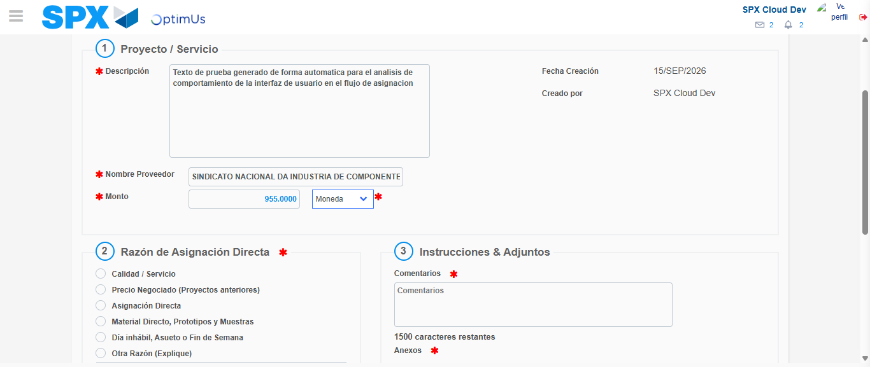Image file-name: QC_Testing-tc002_SPX_Dev5_Crear_Requisicion_Spot_Con_FAD_Tipo_Cobro_CC-1789483576810

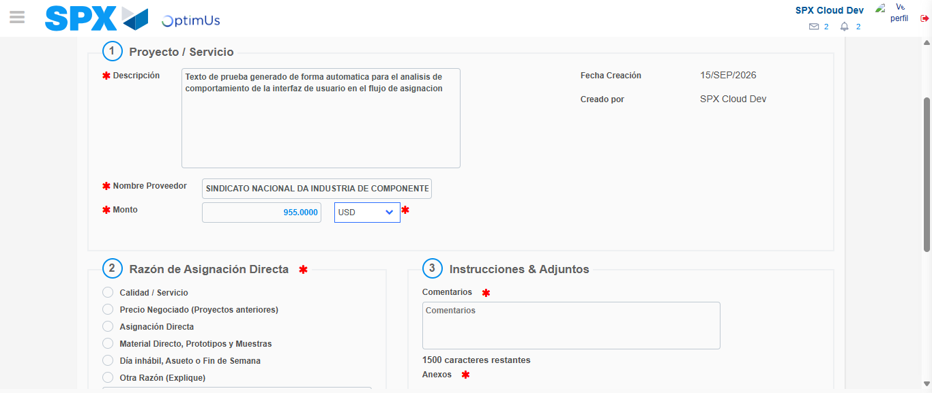Image file-name: QC_Testing-tc002_SPX_Dev5_Crear_Requisicion_Spot_Con_FAD_Tipo_Cobro_CC-1789483577218

Image file-name: QC_Testing-tc002_SPX_Dev5_Crear_Requisicion_Spot_Con_FAD_Tipo_Cobro_CC-1789483577472

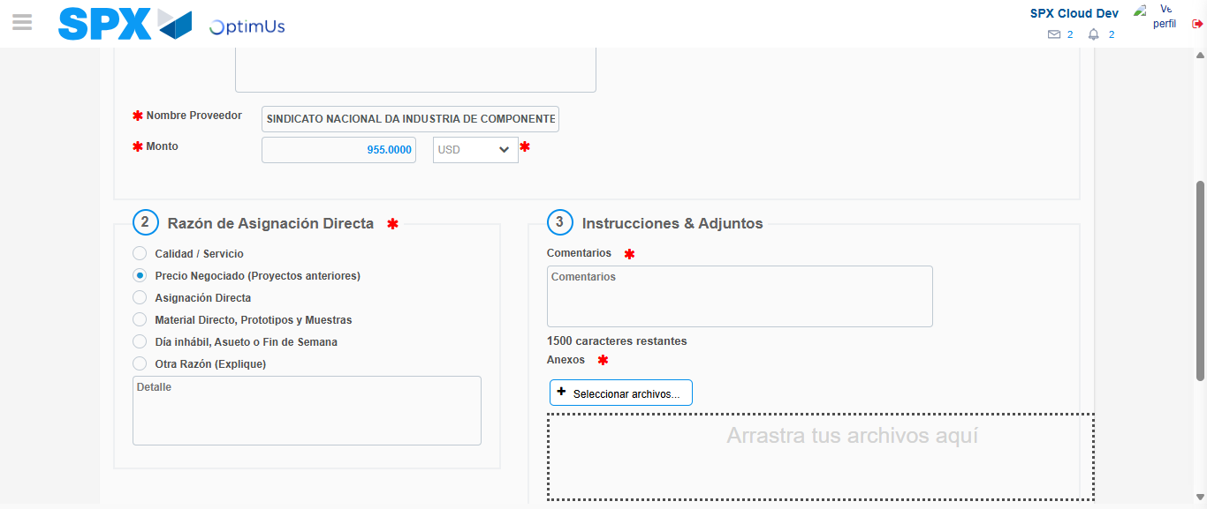Image file-name: QC_Testing-tc002_SPX_Dev5_Crear_Requisicion_Spot_Con_FAD_Tipo_Cobro_CC-1789483578318

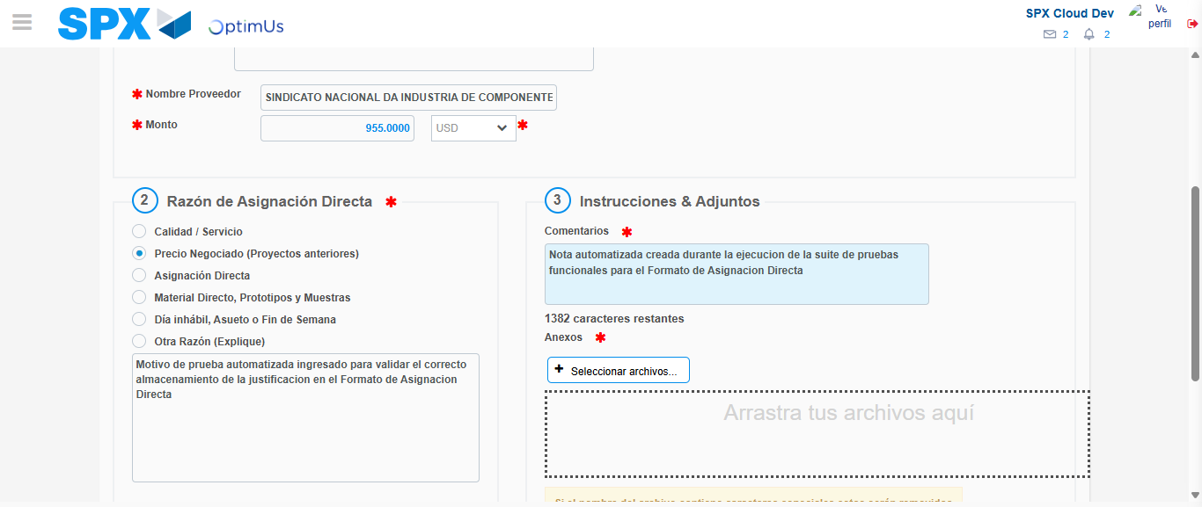Image file-name: QC_Testing-tc002_SPX_Dev5_Crear_Requisicion_Spot_Con_FAD_Tipo_Cobro_CC-1789483589523

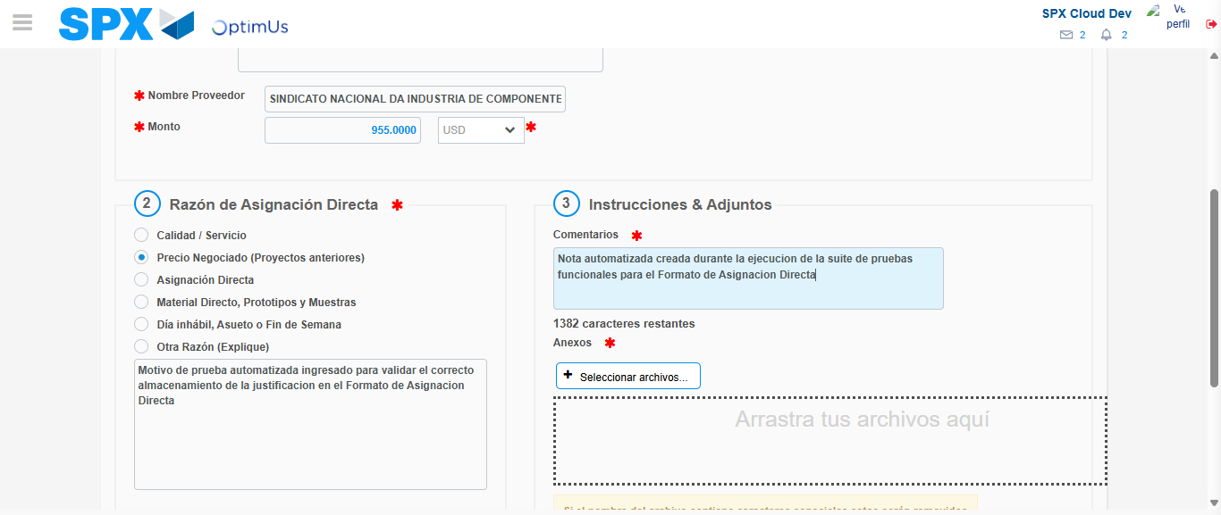Image file-name: QC_Testing-tc002_SPX_Dev5_Crear_Requisicion_Spot_Con_FAD_Tipo_Cobro_CC-1789483590038

Step 4 - Data Capture Spot Buy Requisition: Data captured correctly
Image file-name: QC_Testing-tc002_SPX_Dev5_Crear_Requisicion_Spot_Con_FAD_Tipo_Cobro_CC-1789483563847

Image file-name: QC_Testing-tc002_SPX_Dev5_Crear_Requisicion_Spot_Con_FAD_Tipo_Cobro_CC-1789483564040

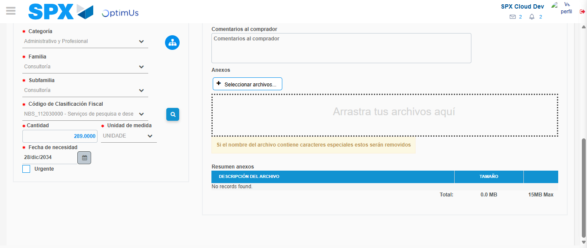Image file-name: QC_Testing-tc002_SPX_Dev5_Crear_Requisicion_Spot_Con_FAD_Tipo_Cobro_CC-1789483605696

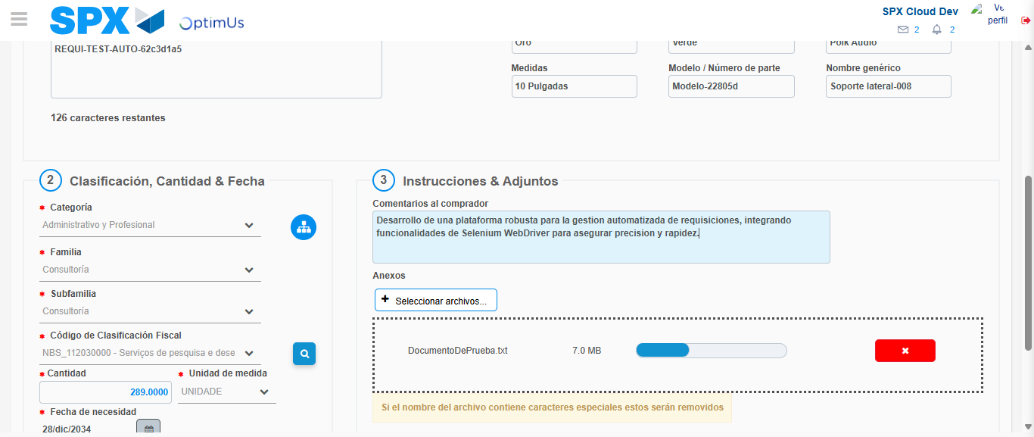Image file-name: QC_Testing-tc002_SPX_Dev5_Crear_Requisicion_Spot_Con_FAD_Tipo_Cobro_CC-1789483606490

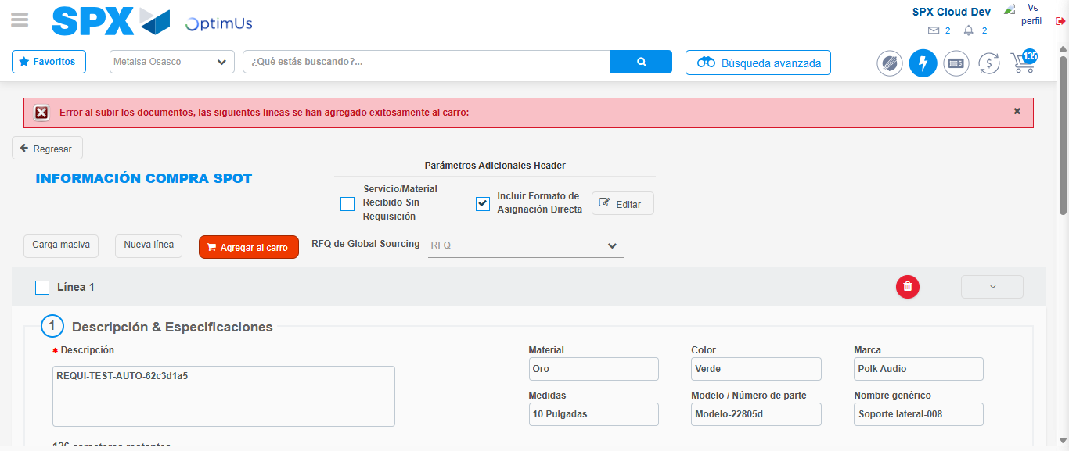Image file-name: QC_Testing-tc002_SPX_Dev5_Crear_Requisicion_Spot_Con_FAD_Tipo_Cobro_CC-1789483620194

Step 8 - Return to Main Page SPX : Return to Main Page SPX
Image file-name: QC_Testing-tc002_SPX_Dev5_Crear_Requisicion_Spot_Con_FAD_Tipo_Cobro_CC-1789483553641

Image file-name: QC_Testing-tc002_SPX_Dev5_Crear_Requisicion_Spot_Con_FAD_Tipo_Cobro_CC-1789483554330

Image file-name: QC_Testing-tc002_SPX_Dev5_Crear_Requisicion_Spot_Con_FAD_Tipo_Cobro_CC-1789483563550

Image file-name: QC_Testing-tc002_SPX_Dev5_Crear_Requisicion_Spot_Con_FAD_Tipo_Cobro_CC-1789483622460

Image file-name: QC_Testing-tc002_SPX_Dev5_Crear_Requisicion_Spot_Con_FAD_Tipo_Cobro_CC-1789483622607

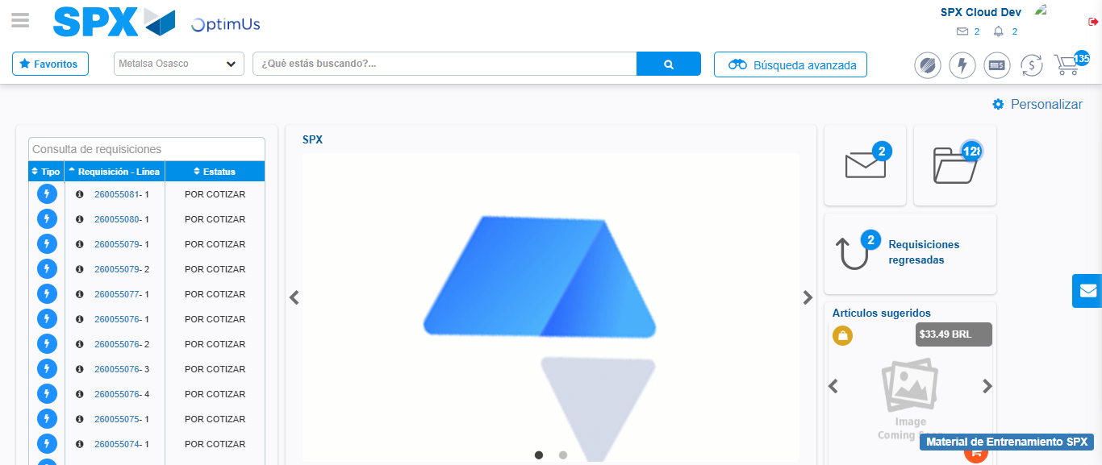Image file-name: QC_Testing-tc002_SPX_Dev5_Crear_Requisicion_Spot_Con_FAD_Tipo_Cobro_CC-1789483643771

Step 9 - Log Out : Log Out SPX
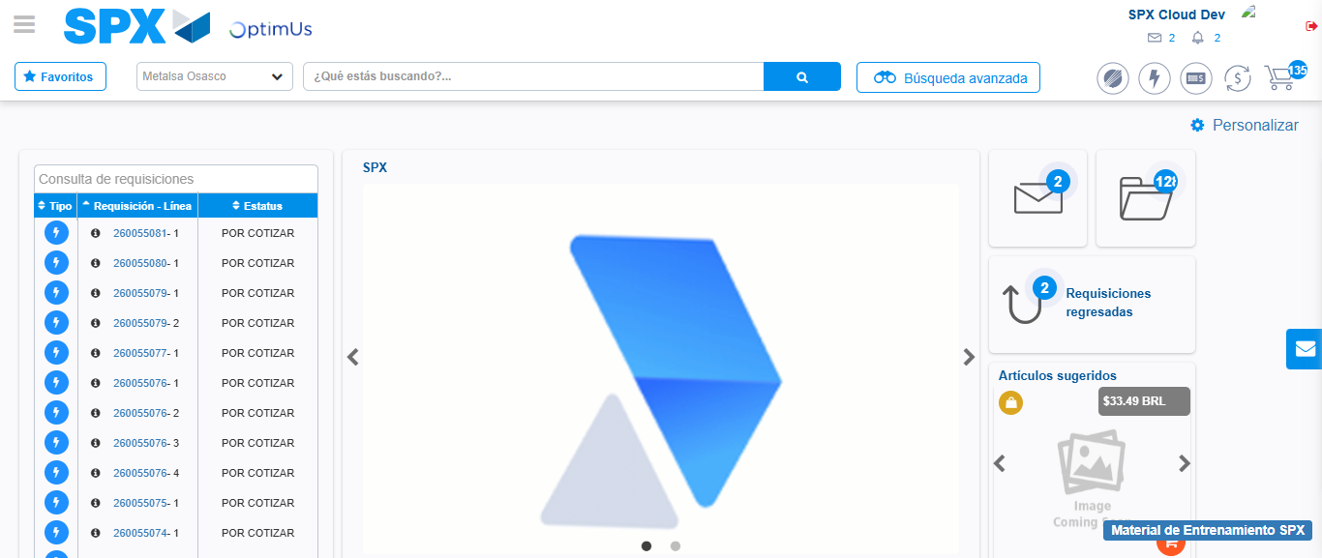Image file-name: QC_Testing-tc002_SPX_Dev5_Crear_Requisicion_Spot_Con_FAD_Tipo_Cobro_CC-1789483644071

